**CS-230 Software Engineering**

A1 Object-Oriented Design Document

**2.1.1 Candidate Classes and Responsibilities**

|  |  |
| --- | --- |
| **Player** | |
| Responsibilities | Collaborators |
| inventory (Holds the tokens, keys and other items) | Cell  Collectables  Level  Enemies  LevelSelect |
| Restart Check (If Player lands on a kill cell then new instance of player (resetting inventory) (in Profile) |
| goal (ends the game to then be presented with |
| move (manipulation of direction and cell moves within level it will check what cell the next move will land on then run that event (teleport etc.) |

Player-This will hold the attributes that the player holds to use within each level, it will respond to different events like teleportation, goal, kill calls, doors etc.

(Subclass of Moveable) (Author- Ciara and Bryony)

|  |  |
| --- | --- |
| **Profile** | |
| Responsibilities | Collaborators |
| Current Level (Based on levels completed (linked list implementation)) | Level  LevelSelect  MainMenu |
| Store Name of profile |
| Hold save (Holds the save file of the player that has left midway through the game) |

Profile- These are the instances of profiles that users will have to record their current progress in the level, along with their high scores. There will be multiple instances of Profile so that users can compete against each other for the highest score. This could also be used if we were going to save progress of a level if the user quit before finishing, as we could save their current location and attributes to the Profile for when they log back on.

(Own Class) (Author- Ciara and Johannes)

|  |  |
| --- | --- |
| **Cell** | |
| Responsibilities | Collaborators |
| Abstract Class all cell types inherit from cell cords/location (x , y) linked list | MapReader  Moveable |
| Adjacent Cells (north, east, south, west) |
| Cell Type (The type of cell) |
| Is cell solid (can it be walked though for enemies, players can go to individual classes that inherit from cell to see if they meet criteria to pass) |

Cell- This an abstract class that will hold all the different cell types, it mainly holds the type and the position as well as adjacent cells.

(Super class of Ground and Wall) (Author- Ruth and Jake)

|  |  |
| --- | --- |
| **Smart Enemies** | |
| Responsibilities | Collaborators |
| Position (holds the position of itself) | Level  Player  Cell |
| Player Position (holds the players current position (gets from level class)) |
| Shortest Route (Calculates shortest route from its current position to players position) |
| move (moves into the next cell only if it isn’t wall cell for inherited enemy class) |
| If no path available to player, then moves to random valid cell |

Smart Enemies-This class will only hold the characteristics of the smart enemy, as it’s a subclass of Enemies. Its main function is to move along the shortest route possible to the player so that it can kill it.

(Sub Class of Enemies (Subclass of Moveable)) (Author- Tom and Rohini)

|  |  |
| --- | --- |
| **Level** | |
| Responsibilities | Collaborators |
| Level Name (e.g. level1) | LevelSelect  Profile  Player  Enemies  MapReader |
| Top Score (Stores the top 3 scores for each instance of level and checks that if the score has been beaten) |
| Keeps track of what is within the level and location (gets the enemies etc.) |
| Load level (this starts the time and the screen to present the level with the current positions) |
| Holds the current score and also can change the start score counter to whatever was stores if file was saved midway through level. |
| Saves player to profile every move player takes |

Level-This is the class that will hold all the data for the level, making it easy to save the current progress. It will also hold the 3 highest scores, and the locations of all the Moveables.

(Own Class) (Author- Johannes)

**2.1.2 Class Diagrams**

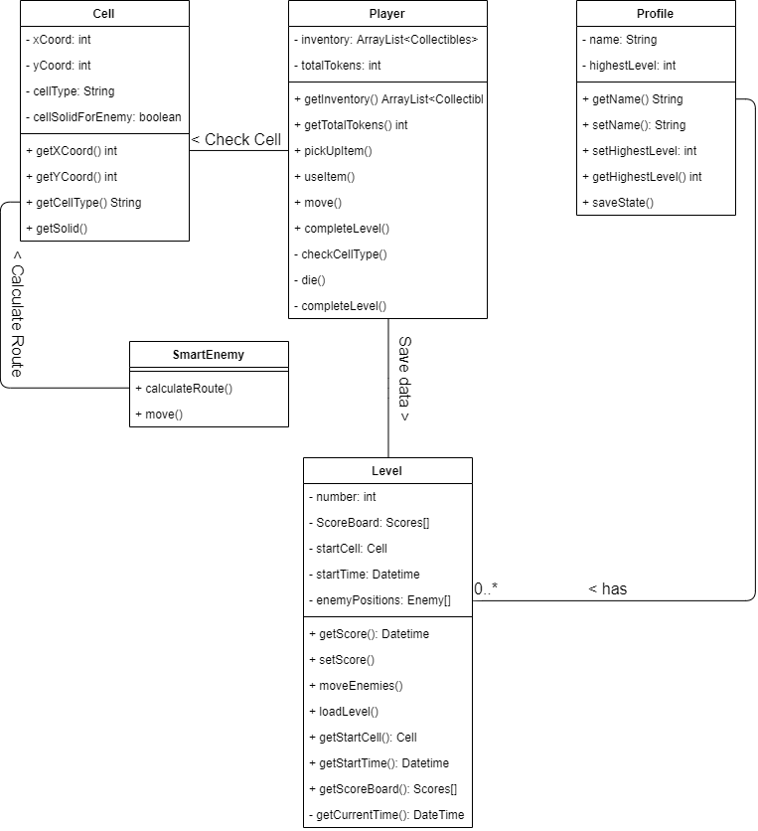

**Collaborations**

**Profile-Level –** Each instance of a profile stores the information about the completed levels. If no levels have been started, this data will be empty, and no instances of Level will be in Profile. As levels are saved/completed, the Profile will update to show if the Level is complete or not, the score, and will store this.

**Player-Level** – When the Level is saved, all the information and data about the level must be saved, such as the score and the positions of each enemy. As well as this, the player position must be saved as well as the inventory of the player.

**Player-Cell** – When moving, the player must perform a check to see if the cell that they attempt to move into is valid. The cell will then return its type and the Player class will handle the data accordingly. For example, if the player attempts to walk into a Wall cell, they will not move, as they can’t move into it.

**SmartEnemy-Cell** – To calculate the shortest route to the player, the enemy must check each cell for their type and the adjacent cells in the direction of the player to find a path. Each cell would return the relevant information until the shortest route has been found.

**Complex Behaviours**

**SmartEnemy.CalculateRoute()** -This method should find the shortest path between the smart enemy and the player, this should be constantly changing as player moves around the grid. This will be implemented by using the shortest path algorithm. This class will need to collaborate with player to find the player position and level to be able to find valid routes for the enemy to go e.g. not through walls etc.

**Level.Load()**-This method loads in the level from the file where the game info is stored, this could be a previously saved level which is now being resumed by the player. The load method will read in the ASCII text file so it can be printed to the screen. Load game will need to collaborate with profile to produce the grid with the objects in the correct positions.

**Level.CompleteLevel()** – This method should be called once the player has successfully reached the goal. getScore should be used to calculate and save the players score for the level. The player’s inventory should be cleared, and their total number of tokens reset to 0. HighestLevel should be incremented using setHighestLevel. The scoreboard should be displayed, then level menu.

**Player.Move()** – Dependent on keys pressed by player, call move up/down/left/right appropriately. Call checkCellType to determine what type of cell the player wants to move onto. Dependent on cell type call appropriate methods to use items from inventory such as keys to open doors, move the player onto the cell therefore changing their coordinates, or kill the player for example.

**Profile.SaveState()** - This is a method that will be used if the Profile exits the game midway through the level, once they exit the current level then the instance of the player will be saved to player as well as the level as you need to keep the enemies position and the tokens picked up. Saving these to profile will mean when the person goes back onto their profile, they will then be able to load their game at the currently saved place, making sure all the entities are in the same place as before so no bugs to exploit.

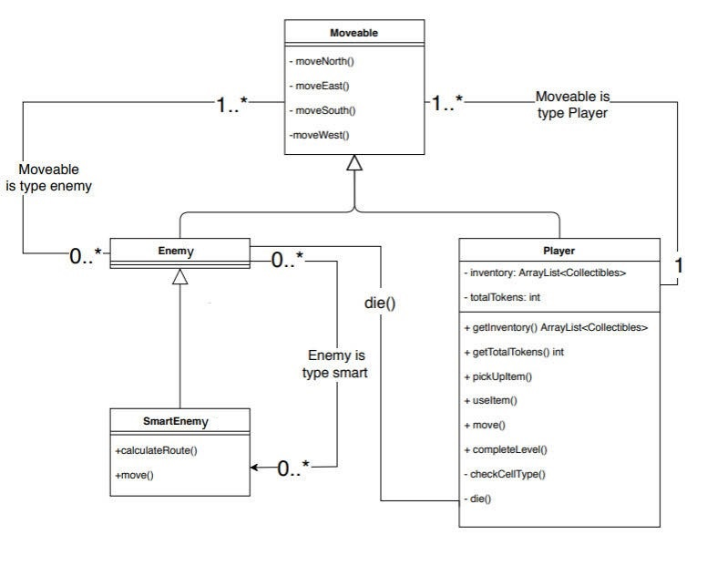**2.1.3 Hierarchy Descriptions**

We have chosen to make player and enemies subclasses of moveable. This logically makes sense because they are the only objects in the game that move. They also always move at the same time. The directed move methods in moveable should just change the coordinates of the moveable so it moves to another adjacent cell in the game. Enemies is an abstract class because all enemies are of a specific type that dictates how they move around the game. Therefore, enemies should never be instantiated. All subclasses of enemies, and player should override a moveable method move(). This method dictates how the moveable moves via conditional statements, algorithms etc. The benefit to having this type of hierarchy with moveable as a parent class, is that we expect during implementation more methods will be found and written which will be used by enemies and player, meaning they can be inherited from a parent class making code more efficient. Enemies only collaborate with player when they move onto the same cell in the game, killing the player.

**2.1.4 Level File Format**

 The first line of the level file defines the height and width of the map using the two comma separated values. Line 2 till line height of map+1 will be an ASCII representation of the cells on the map that do not require extra data to define. As you can see from our example file, we have used the symbols explained below and created a file that should meet specification. All the symbols given here are ones that can be represented straight into the file as symbols as with the more complicated entities that have to be written under the map layout.

**Our theme for this game will be jail so we have decided on changing the generic water and fire to a prisoner and dog with the only ways of passing cigarettes or a bone respectively. The graphics are the game will also depict this, as well as the enemies being different level guards. Normal doors maybe temporary walls, windows or wire Fence which the player will collect shovel, hammer and wire cutters. Token doors will be doors with a passcode and the user(prisoner) should get a number of pieces of paper holding the code to be able to get through the door. The teleports will be tunnels already made between the two locations. The player will most likely start in a cell like location and the goal may be an exit of the jail.**

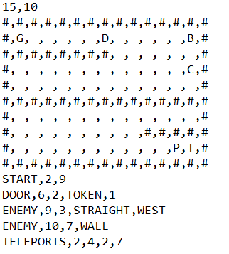

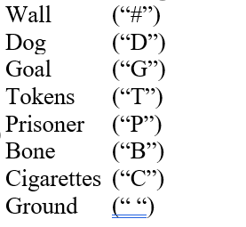

Wall as you can assume is a block that not entity should be able to access that’s why the outer rim of the map is that format. As discussed above the dog and prisoner can be bribed with the bone and cigarettes to allow access pass. Once you have these items you can use them thought the level however when you start a new level this item will be taken out of the inventory.

Ground cells can then be replaced by any cells that are defined later, for example door cells like shown in example above.

The next line after the map shows the start position “START” of the player, represented by two comma separated values (x and y coordinates).

After this, any extra cells that have not been defined are done so, this is done by specifying the type of cell followed by any relevant data in the comma separated list.

For door this would be “DOOR” followed by the x and y coordinates, and then the type of the door. There are a few different types of doors that could come up for example coloured doors would be “DOOR, X, Y, RED” stating the type of coloured door it is and what key colour is needed to open the door. For a token door then you need to say its type is “TOKEN” but also state how many token s are needed to open the door which would subsequently lead to subtracting that number from the users’ inventory and reverting the door cell into a ground cell. Teleporters “TELEPORTS” are defined in pairs, with the x and y coordinates of each as the data in the list for example the first two cords are the first teleport pad and the second two are the corresponding pads, this is in place to stop their being redundant teleport pads and also to that if there are multiple teleport pads in the level they won’t get mixed up. The key is a “KEY” followed by its x and y coordinates and the colour of the key. Enemies has a symbol of” ENEMY” denoting them, they have x and y coordinates followed by the type of enemy. Straight Line enemies(Guards that could possibly be blind) also need the direction and something to tell what side it is following where as others don’t need that extra information.